



**Module Code & Module Title**

**CC5068NI– Cloud Computing & IoT**

**Assessment Type**

**10% Proposal Report**

**Semester**

**2022 Spring**

**Group members**

|  |  |
| --- | --- |
| **London Met ID** | **Student Name** |
| **20049139** | **Bikesh Parajuli** |
| **20049142** | **Bisham Kunwar** |
| **20049253** | **Sushila Gyawali** |
| **20049453** | **Ritesh Timalsina** |
| **20049261** | **Ujwal Bhattarai** |

**Assignment Due Date: 17th April 2022**

**Assignment Submission Date: 17th April 2022**

**Word Count: 933**

*I confirm that I understand my coursework needs to be submitted online via Google Classroom under the relevant module page before the deadline in order for my assignment to be accepted and marked. I am fully aware that late submissions will be treated as non-submission and a mark of zero will be awarded.*

**Acknowledgment**

We like to express our thanks of gratitude to the module teachers Mr. Sugat Man Shakya and Mr. Sujil Maharjan, for giving us the opportunity to work on this IOT project of the topic, Water monitoring and management, which also helped us in doing much research and we came to know about various things related to IOT and increase our knowledge on the respective topic.

We are also helmed in humbleness to all those friends who helped us put on these ideas to our project. Despite the busy days, they provided unique ideas and managed time to help us in this project. Thanks again to all who helped me.

**Abstract**

Due to an excess supply of water, most people in residential areas face the problem of running out of water and overflowing water tanks. It becomes difficult for users to judge the level of water in water tanks, resulting in users running out of water when they need it most. Even if the pump is turned on, users may not notice when the water tank is full, resulting in an overflow. To resolve issues with water tanks, a water tank monitoring system can be used.

It is also possible to use a sensor to monitor the water level, so that if the level falls below a certain threshold, a notification is sent to the user to turn on the pump. When there is an overflow of water in the water tank, the sensor detects the water level so that the pump user receives a notification to turn off the pump if the water level rises above a certain level. This system eliminates water waste.

**Table of Contents**

1. Introduction 1

1.1. Current Scenario 1

1.2. Problem Statement and Project as a solution 1

2. Aim and Objectives 2

2.1. Aim 2

2.2. Objectives 2

3. Background 3

3.1. Expected outcomes and Deliveries 3

3.2. Requirement Analysis 4

3.2.1. Hardware 4

3.2.2. Software 4

4. Individual Contribution Plan 5

5. Conclusion 6

References 7

**List of Figures**

Figure 1: System Architecture of the project 3

**List of Tables**

Table 1: Individual Contribution Plan 5

# Introduction

Internet of things (IoT) is one of the leading platforms in the information technology field where nearly every industry is affected by it. The following project is also based on the principle of IoT and an IoT system is to be developed coinciding the present scenario, problem statement and project as a solution. The project is named ‘**Water Tank Monitoring and Management**’ which primary purpose is to maintain, monitor, and manage the level of water inside the tank.

Nowadays, overflow of water in water tanks because of excess supply of water is very common. Since it is difficult for the people to know whether the water level has reached a certain point where there might be overflow, the proposed device will assist in mitigating that problem.

## Current Scenario

Water monitoring has been a migraine from a long time. Hence, several people have tried to solve the problem and come up with some solutions. One of the projects named Water Tank Monitoring System came with an idea that when the lower-level sensor of the tank is reached by water; empty tank, a notification would be sent to the android application used by the user. The user would then turn on the motor on receiving the notification. Similarly, the motor would be turned off automatically when the level of water reaches higher level sensor (Nishmitha, et al., 2019).

## Problem Statement and Project as a solution

Water monitoring problems are not news. It is the problem of every person living in the society who owns a water tank at least. Whenever water tank is to be filled, there is always a thought that overflow might be an issue if constant attention is not given during the water filling process.

Also, Whether the water tank is empty or not can only be found out when either water does not come out from the tap or checking the tank regarding the quantity. Thus, this project will try to solve that problem and contribute to solving this water related issue.

# Aim and Objectives

## Aim

The primary aim of this project is to create the system that can monitor the water level of the tank and notify when required.

## Objectives

* The system is expected to perform monitoring of water tank by measuring water level using sensors.
* By visualizing the water retention time in the tank, the system is expected to identify lowering water levels.
* The system is expected to notify when there is overflow of water.

# Background

## Expected outcomes and Deliveries

As it is known that water tank overflow and emptiness has been the problem of each one having owned a water tank. This problem has created a lot of rufus in everyone’s house. Thus, the following project is an IoT based Water Monitoring and Management system which would assist in knowing whether the water tank has reached maximum or minimum capacity of water to avoid overflow and scarcity of water.

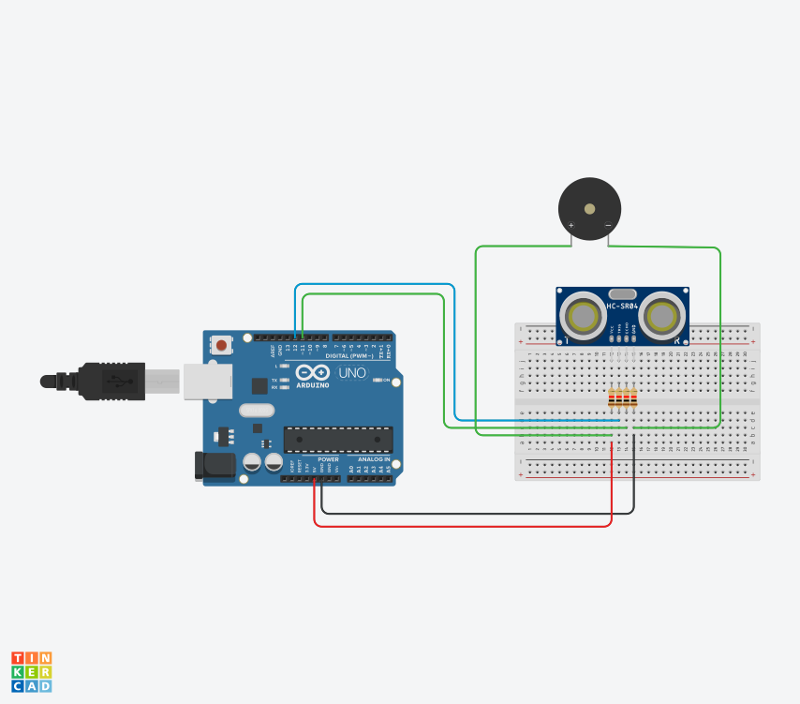

Figure : System Architecture of the project

The above diagram showcases the system architecture of the device which is a Water Monitoring and Management system with necessary equipment required to complete the project.

## Requirement Analysis

### Hardware

* **Arduino Uno**: Arduino is an open-source electronics platform that uses simple hardware and software to make it easy to use. Arduino boards can take inputs such as light from a sensor, a finger on a button, or a Twitter message and convert them to outputs – such as turning on an LED, triggering a motor, or publishing anything online. (Arduino, 2022)
* **Breadboard**: Before finishing any circuit design, a breadboard is used to quickly develop and test circuits. Many holes on the breadboard allow circuit components like as ICs and resistors to be added. (HIBP, 2022)
* **Ultrasonic Distance Sensor**: Ultrasonic sensors use ultrasonic waves to measure distance. The sensor head sends out an ultrasonic pulse, which is reflected to it by the target. Ultrasonic sensors use the time between emission and reception to calculate the distance to the target. (KEYENCE CORPORATION, 2022)
* **Piezo**: Piezo electric speakers are commonly employed to generate sound in digital quartz watches and other electronic devices, and they are also utilized as tweeters in less expensive speaker systems like computer speakers and portable radios. They are also employed in sonar systems to generate ultrasound.

### Software

* **Arduino IDE**: The open-source Arduino Software (IDE) makes it easy to write code and upload it to the board. This software can be used with any Arduino board.

# Individual Contribution Plan

The individual contribution of each member of the group to complete the project are mentioned below:

|  |  |
| --- | --- |
| **Name** | **Task** |
| Bikesh Parajuli | Device Management and checking wiring between each device. |
| Bisham Kunwar | Programming, creating automated scripts for device used. |
| Ritesh Timalsina | Debugging and testing. |
| Sushila Gyawali | Documentation, formatting, and presentation. |
| Ujwal Bhattarai | Device monitoring and implementation. |

Table : Individual Contribution Plan

# Conclusion

Water shortage and Water overflow has been the problem of every water tank available in everybody’s home. To check whether the level of water has reached a certain level and to get notified of it would be helpful in mitigating the problem of overflow and scarcity at a certain time.

The created Water Monitoring and management system helps to reduce the wastage of water due to overflowing by notifying about the water level when it reaches the threshold limit. The system also notifies then the water is below the critical level so that we will be aware when to fill up the tank. As overflowing of the tank is the major contributor in wastage of water, this proposed system can be very beneficial.

# References

Nishmitha, et al., 2019. *Water Tank Monitoring System.* Mijar, Moodbidri, www.ijert.org.

Arduino, 2022. *What is Arduino? | Arduino.* [Online]   
Available at: https://www.arduino.cc/en/Guide/Introduction  
[Accessed 17 April 2022].

KEYENCE CORPORATION, 2022. *What is an Ultrasonic Sensor? | Sensor Basics: Introductory Guide to Sensors | KEYENCE.* [Online]   
Available at: https://www.keyence.com/ss/products/sensor/sensorbasics/ultrasonic/info/  
[Accessed 17 April 2022].

HIBP, 2022. *HIBP.* [Online]   
Available at: https://hibp.ecse.rpi.edu/~connor/education/breadboard.pdf  
[Accessed 17 April 2022].